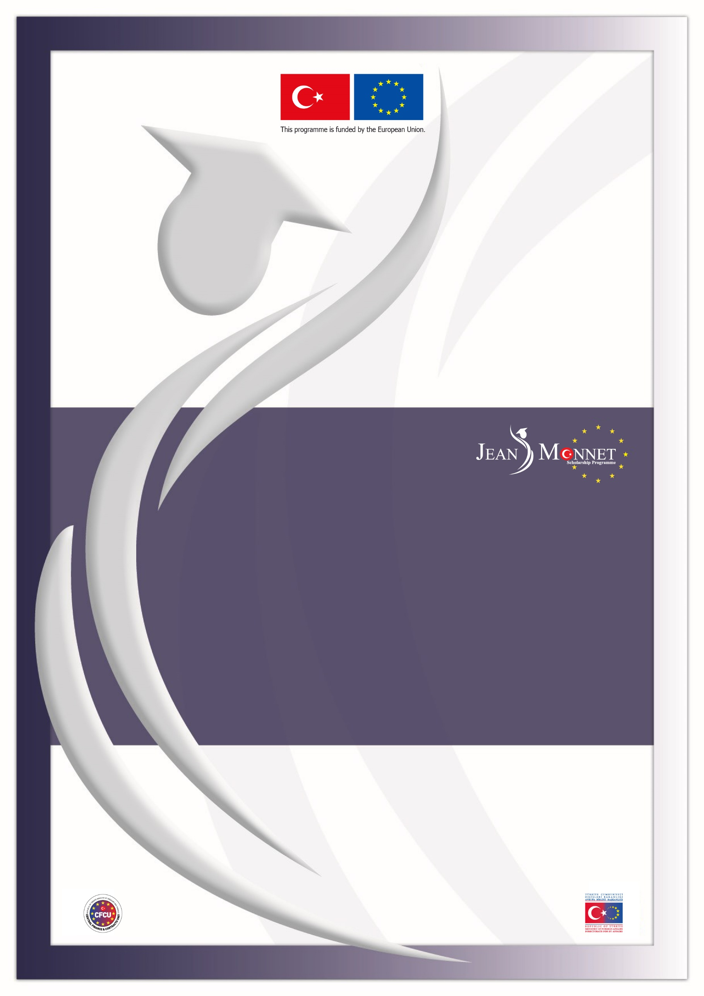

**Directorate for EU Affairs Central Finance and Contracts Unit Delegation of the EU to Türkiye**

**TR2022/W2T2/A03/OT01-2**

**2025-2026 ACADEMIC YEAR**

**JEAN MONNET SCHOLARSHIP PROGRAMME**

**CLARIFICATIONS**

**IMPORTANT NOTICE**

The questions received from potential applicants for the 2025-2026 academic year Jean Monnet Scholarship Programme together with their answers can be seen below. These questions and answers are valid for the 2025-2026 academic year Announcement and the questions and clarifications of the previous academic years do not set a precedent for the mentioned academic year.

Clarifications constitute an essential part of the Announcement; for this reason, the applicants must read the Clarifications document very carefully and pay attention to the details while applying to the scholarship.

Please note that the **replies given to the questions on the eligibility are provided solely for the question asked without consideration of whether the other eligibility criteria stated in the Announcement are fulfilled or not.**

As stated in Section 2.3.3. Important Notes for Application of the 2025-2026 Academic Year Jean Monnet Scholarship Programme Announcement, **questions related to the issues clearly stated in the Announcement document will not be answered in the Clarifications document.**

In the interest of equal treatment of applicants, the contracting authority or the Directorate for EU Affairs cannot give prior opinion/approval neither during application nor during evaluation stages, on:

* the acceptability/adequacy of the application documents,
* the sector from which the applicant should make an application,
* the eligibility of the academic programmes to be pursued,
* the relevance of the field of study (i.e. EU acquis chapter) with the academic programmes planned to be pursued.

|  |  |
| --- | --- |
| **SECTOR AND APPLICATION CRITERIA** | |
| **1** | Q: I have graduated from an undergraduate/graduate programme. However, I neither started to work, nor am I registered to a master’s degree/PhD programme. May I apply?  C: No. In order to be eligible, applicants should either be working in Türkiye on a professional basis (i.e. under a social security network, in return for a wage) in public sector or private sector or university sector as academic/administrative staff or be senior undergraduate students/ master’s/PhD students in the universities in Türkiye. |
| **2** | Q: I am currently pursuing graduate study abroad and at the same time working in the private/public sector in Türkiye. Can I apply to Jean Monnet Scholarship Programme?  C: Those who meet the required criteria and who can submit the required documents of the relevant sector may apply. |
| **3** | Q: My undergraduate programme has been extended one more semester. Therefore, I am in the 5th year of a 4-year programme. May I apply as a senior undergraduate student?  C: Yes. As long as applicants are registered as senior undergraduate students at the time of application, having extended their programmes does not constitute a problem. Please also note that awardees who were senior undergraduate students while applying to this Announcement, should submit a Graduation Certificate/Diploma and transcript showing the graduation CGPA related to their undergraduate programme before the contract signature. |
| **4** | Q: I am currently a senior undergraduate student and will graduate in January-February 2025. Looking at the application criteria it appears I am eligible to apply. However, during the written exam and at the time the scholarships are granted I will be unemployed. May I still benefit from the scholarship to pursue graduate study/research?  C: Yes. As long as applicants are registered as senior undergraduate students at the time of application, having graduated and being unemployed in the following stages does not constitute a problem. Please also note that awardees who were senior undergraduate students while applying to this Announcement, should submit a Graduation Certificate/Diploma and transcript showing the graduation CGPA related to their undergraduate programme before the contract signature. |
| **5** | Q: May I benefit from the programme if I apply as an academic staff, then retire and enrol in a graduate programme?  C: No. The candidates/awardees will not be allowed to change their sectors. Those who applied as employees from the “public or private sector” or as academic or administrative staff from the “university sector” should still be working in that sector once they are awarded the scholarship. |
| **6** | Q: I am a graduate student at a university in Türkiye. Is it possible to change my university and/or programme in the second term?  C: Those who applied from the “university sector” as graduate (master/PhD) student should either have graduated from their programmes or still be maintaining their student status before the submission deadline of the contracting documents. Yes, it is possible to change university and/or programme as long as the applicant maintains and proves the graduate student status. |
| **7** | Q: Is it possible if the applicant leaves work permanently or has periods of unemployment after the application?  C: Applicants have to submit an employment letter in order to prove they are still working in the **same sector** after they are awarded with the scholarship. It is important to note that in any stage of the scholarship programme, applicants may be required to submit additional documents when the information provided is unclear and thus prevents the evaluation committee/contracting authority from conducting an objective assessment. |
| **8** | Q: I will apply from the private sector. Am I expected to be still working in the same institution when I am awarded? After the award, can I resign or use my leave of absence?  C: Applicants have to submit an employment letter in order to prove they are still working in the **same sector** after they are awarded with the scholarship. In this respect, they are allowed to change their institution as long as they are still in the same sector. It is up to the applicants’ decision whether they would like to benefit from the scholarship by using their leave of absence or resigning. |
| **9** | Q: I am a student in an open education (*Açık Öğretim*) graduate programme. May I apply?  C: Yes. |
| **10** | Q: May I apply as a master student enrolled in a distance education from a university in Turkish Republic of Northern Cyprus (TRNC)?  C: No. Only students enrolled in the universities located **in Türkiye** can apply. |
| **11** | Q: I have graduated from one of my major undergraduate programmes. I am still enrolled to the other major undergraduate programme. May I apply?  C: Yes, as long as you are enrolled to your other major undergraduate programme as a senior undergraduate student you may apply. |
| **12** | Q: Can contracted public sector employee apply from the public sector?  C: Yes, they can apply. Applicants should decide from which sector (public sector, university, private sector) they will be applying according to the legal status and legislation of their institution and should submit the required application documents accordingly. Please also pay attention that scholars should certify with appropriate documents that they belong to the same sector during the contracting process. |
| **13** | Q: I work at a company whose shares belong to “X” institution which is established by law. May I apply from the public sector?  A: During the application stage, in the interest of equal treatment of applicants, prior opinion/approval cannot be given on the sector from which the applicant should make an application. However, it is recommended that relevant supporting documents are included within the application explaining the sector category selection. |
| **14** | Q: Based on the amendment of the Attorneyship Law, being employed under a social security system will not form a barrier to pursue legal internship as long as it does not present a factual obstacle to the internship. May I apply for a scholarship if I work in the public or private sector under social security during my internship period?  C: Yes. Please also note that only applications from candidates whose retirement/pension insurance premiums are paid is acceptable. |
| **15** | Q: I've been working as a self-employed lawyer since 1st of August 2024 and as I'm under the age of 29 I'm considered as young entrepreneur so my insurance premium is paid by the State. Does this situation constitute any problem for my application?  C: In the scholarship programme “working” means “professional work done under a social security network in return for a wage". As long as the applicants who fulfil the application criteria and submit the required documents it does not constitute an obstacle whether the retirement/pension premiums are paid by the applicant or a third party. |
| **APPLICATION DOCUMENTS** | |
| **16** | Q: I'm working in “X” Company but my payroll/service scheme is formed by “Y” Company. Which institution should I indicate in the Institution of the Applicant part of the Application Form?  C: Prior opinion/approval cannot be given on the acceptability/adequacy of the application documents. However, applicants should submit the application documents which reflect their accurate status. In case of any discrepancy, it is recommended that relevant supporting documents are included within the application explaining the situation. |
| **17** | Q: Is it obligatory to submit an additional document stating that the person signing the payroll sheet is an authorised person?  C: No. The applicants who apply from the private sector are expected to submit documents meeting the criteria listed in section 2.3.1.2 of the Announcement. |
| **18** | Q: I'm a personnel of “X” Institution, however I'm seconded at the “Y” Institution. Should I get the official consent letter from both institutions?  C: The consent letter shall be obtained from the institution which has the authorisation to approve the applicant’s academic study via the Jean Monnet Scholarship Programme in the relevant EU member country when he/she is awarded the scholarship. |
| **19** | Q: I'm currently working as a part-time academic in a university. As I'm not working full time, should I submit official consent letter?  C: Yes. |
| **20** | Q: Should service scheme be translated into English?  C: No. |
| **21** | Q: May I apply with the application documents which are obtained at different dates?  C: Application documents obtained at different dates **do not constitute an obstacle** as long as the application documents fulfil the relevant criteria mentioned in the Announcement and reflect the actual status of the applicant. |
| **22** | Q: In the Application Form should I write down the name of the institution I'm currently working or studying in English?  C:Application form should be filled in one of the EU official languages. |
| **23** | Q: Can we use Turkish characters when filling the English Application Form?  C: You may use Turkish characters for proper nouns. In case any problem occurs while using Turkish characters, you can use the closest English character. |
| **24** | Q: Is the undergraduate transcript taken from e-state system eligible or should the document be originally signed by the university?  C: The undergraduate transcript obtained from the university or e-state system, in the language provided by the university/e-state system including the official validation of the university/e-state system (i.e. handwritten signature or electronic verification such as QR code/barcode/verification link) (please see Section 2.3.3 Article 19 of the Announcement) is eligible. Please also note that **senior undergraduate students** should submit an undergraduate transcript bearing a date which is in dd/mm/yyyy format and later than the publishing date of the Announcement. In case an undergraduate transcript obtained from the e-state system is submitted, it is solely the applicant’s responsibility to make sure that the transcript includes up-to-date information. The date of the information provided by the university (as stated at the end of the document obtained from the e-state system) should be a date later than the publishing date of the Announcement. |
| **25** | Q: May I submit an undergraduate transcript bearing a date in mm/dd/yyyy format instead of dd/mm/yyyy format which is indicated in the Announcement?  C: Yes. |
| **26** | Q: As a senior undergraduate student, I took courses abroad within the Erasmus Programme last term, which is not yet reflected in my signed official university transcript. Can I apply?  C: Prior opinion/approval cannot be given on the adequacy of the application documents. However, you are recommended to submit supporting documents (preferably taken from the university) explaining your situation. |
| **UNDERGRADUATE CGPA** | |
| **27** | Q: Although my CGPA appears to be lower than 2.70/4.00, according to the 100-based grading system it is over 70. May I apply?  C: Yes. Applicants should have a minimum undergraduate CGPA of either 2.70/4.00 **or** 70/100. It is solely the applicant’s responsibility to submit a conversion document such as an official letter/e-mail from the applicant’s university or the university’s regulation showing the equivalence of his/her CGPA in the acceptable grading systems (i.e. 100 **or** 4.00). If the equivalence of the CGPA in the acceptable grading system is already indicated on the transcript provided by the university, the applicants do not have to submit separate conversion documents. |
| **28** | Q: I'm a senior undergraduate student with a CGPA lower than 2.70/4.00. However, I am planning to have a higher CGPA towards the end of the year. May I still apply with my current CGPA?  C: The CGPA stated on the undergraduate transcript submitted at the time of application will be taken into consideration. During the contracting process, awardees who were “senior undergraduate students” while applying to this Announcement should submit an undergraduate transcript showing that their graduation CGPA is higher than either 2.70/4.00 **or** 70/100. Please also see Clarification-27. |
| **29** | Q: Is there a requirement regarding duration of work experience when applying for a scholarship?  C: Minimum 36-month work experience is only required from the applicants whose CGPA is less than 2.70/4.00 **or** 70/100. Otherwise, there is no minimum work experience requirement for application. |
| **LANGUAGE PROFICIENCY CERTIFICATES** | |
| **30** | Q: I have a language proficiency certificate for the test I took on 5 November 2022. May I apply with this certificate based on the fact that it is valid for 2 years?  C: Yes, you may apply with the language proficiency certificate taken on 5 November 2022 if it is valid for 2 years. |
| **31** | Q: Should I take IELTS Academic on computer or online or paper?  C: All are acceptable for applying to the Scholarship Programme. |
| **32** | Q: Is there a specific exam centre (e.g. public building, etc.) that I should take the foreign language proficiency exam?  C: No. Valid foreign language proficiency certificates, which meet the minimum scores indicated in the Section 3 of the Announcement, are accepted regardless of the location they are obtained. However, please consider that public institutions may have different criteria for the language certificates during the assignment/secondment process. |
| **33** | Q: Can I submit the language proficiency certificate **after** the application deadline?  C: No. |
| **HOST INSTITUTIONS & ACADEMIC PROGRAMMES** | |
| **34** | Q: I'm a graduate student at an English teaching programme. In the Important Note-1 of the Announcement, it is stated that programmes related with teaching are not supported under Education and Culture field of study. May I apply?  C: Mentioned restriction is related with the academic programmes to be pursued under the scholarship programme. There is no restriction related with the current programmes in which the applicants are enrolled in. |
| **35** | Q: Should the master programme be related to the field I am currently working/pursuing a study in? Or can it be in a different field?  C: The Jean Monnet Scholarship Programme considers the compliance of the study field selected with the field of the academic programme to be pursued as well as compliance with the objective of the scholarship. In this manner, the scholarship programme does not take into consideration the compliance of the selected academic programme with the academic or professional background of the applicant. |
| **36** | Q: I'm a research assistant in a university and finished my PhD, I want to work with professors and publish articles in my field. If I'm awarded the scholarship, would it be enough to submit my articles as an output of the research programme?  C: Scholars who conduct research programme are expected to submit an output such as a research report, article, symposium presentation, etc. at the end of their scholarship periods. |
| **37** | Q: Are scholarships granted for post-doctoral study or research?  C: Jean Monnet Scholarships are not limited for master’s degrees only, meaning that scholarships can be granted for post-doctoral studies or research levels for periods of **minimum 3 months, maximum 12 months.** Academic studies longer than 12 months will not be supported even if the scholars are willing to fund the remaining period by their own means. |
| **38** | Q: Are we responsible to find the host university or will you enrol us to the eligible host institutions?  C: It is solely the applicants’ responsibility to identify the suitable academic programmes/host institutions in line with their field of study and to get unconditional offer letter(s) from the academic programmes. |
| **39** | Q: May I pursue an academic programme which is not listed in the Host Institutions Catalogue?  C: Applicants may refer to the Jean Monnet Scholarship Programme Host Institutions Catalogue (available in www.jeanmonnet.org.tr) for examples of graduate programmes in the fields they wish to study. However, eligible programmes are not restricted to the programmes/institutions listed in the subject catalogue. The academic programmes pursued by the previous Jean Monnet Scholars do not constitute a precedent for this academic year and the Directorate for EU Affairs retains the right to give the final decision on the compliance of the programmes with the fields of study and the admission of the scholars to ensure the balanced distribution of the scholars throughout EU member countries. |
| **40** | Q: Why is there no program related to field “Y” in “X” country in the Host Institutions Catalogue?  C: Applicants should identify the EU member countries in which they would like to pursue their academic studies while the application and evaluation processes are going on. It is solely the applicants’ responsibility to get unconditional offer letters from the academic programmes. In the search of programmes related to the EU acquis chapter applied from, it is recommended that the applicants examine the Jean Monnet Scholarship Programme Host Institutions Catalogue which is published in www.jeanmonnet.org.tr website. However, it is important to note that the applicants are not bound by the programmes in the Catalogue. The academic programmes pursued by the previous Jean Monnet Scholars do not constitute a precedent for this academic year. |
| **41** | Q: Should acceptance/offer letters be submitted before or after 5 November 2024?  C: Applicants are not required to submit acceptance/offer letter at the time of application. The applicants shall, however, make their applications to the universities or similar institutions in a timely manner such that they should have their acceptance/offer letters at hand once they are awarded the scholarship. |
| **OTHER** | |
| **42** | Q: Do the responsibilities and obligations of the Faculty Member Training Program (ÖYP) conflict with the scholarship?  C: It's solely the applicants’ responsibility to figure out the obligations stemming from the institutions where they work or study at. |
| **43** | Q: Are the applicants who currently reside or have lived or have studied in the EU member countries eligible?  C: Yes, as long as you fulfil the eligibility criteria stated in the Announcement, you may apply. |
| **44** | Q: Do you provide any supporting documents for facilitating the visa application?  C: Yes, the applicants who are awarded the scholarship are provided with visa letters by the Directorate for EU Affairs once their programmes are approved. |
| **45** | Q: Do you charge an application fee or written exam fee?  C: No. |
| **46** | Q: May I benefit from Jean Monnet Scholarship Programme, if I am the recipient of another scholarship for the same academic study?  C: Jean Monnet Scholarship awards recipients may not benefit from another scholarship for the same duration of study, however, scholars may benefit from tuition fee discounts/waivers of host institution, if any. |
| **47** | Q: I realised that I had not written the statement “Not To be Opened Before Opening Session” when I sent my application documents. Should I re-send the documents with the statement as indicated in the announcement or would it be accepted as it is?  C: No. You do not have to re-submit your application if it is already received and registered by the Central Finance and Contracts Unit. |
| **48** | Q: I was granted a scholarship award for the 2021-2022 academic year and 90% of my award payment was transferred to my bank account. However, before my travel I was diagnosed with cancer, hence I had to withdraw, and I refunded the full amount. So, I could not benefit from the scholarship. May I re-apply for the 2025-2026 academic year? In this case, should the section 7 of the Application Form be answered "Yes" or "No"? Do I have to present any additional documentation?  C: Those who formerly benefited from the Jean Monnet Scholarship may not apply once more. However, you should indicate the situation in your Application Form as “Yes” by elaborating necessary information/details in the comment box, and provide supporting documents regarding your situation together with a petition letter with all the application documents required for application. Your situation may be evaluated by the Evaluation Committee. |
| **49** | Q: Universities may request payments when issuing acceptance/offer letters. Are we responsible for making these payments?  C: It is solely the applicants’ responsibility to identify the suitable academic or research programmes in line with their field of study and to obtain acceptance/offer letter(s) from the academic programmes. On the other hand, the risk of the academic or research programme for which a deposit/tuition fee has been paid not being approved should be noted, as the Directorate for EU Affairs retains the right to give the final decision on the programme approvals to ensure the compliance of the programmes with the fields of study (EU acquis chapters) and the optimal exploitation of the scholarships. |
| **50** | Q: How many acceptance/offer letters do we need to get for the placement process?  C: While submitting only one acceptance/offer letter from an EU country is sufficient for the placement process, the Directorate for EU Affairs has the right to reject an offered academic or research programme to achieve Jean Monnet Scholarship Programme objectives. Therefore, it is highly recommended that the applicants apply and get acceptance/offer letters from at least two academic or research programmes. Additionally, since the relevance of the selected field of study and the programme contents will be evaluated during the application process, it is recommended not to submit programmes that contain identical or very similar courses during the placement process. |