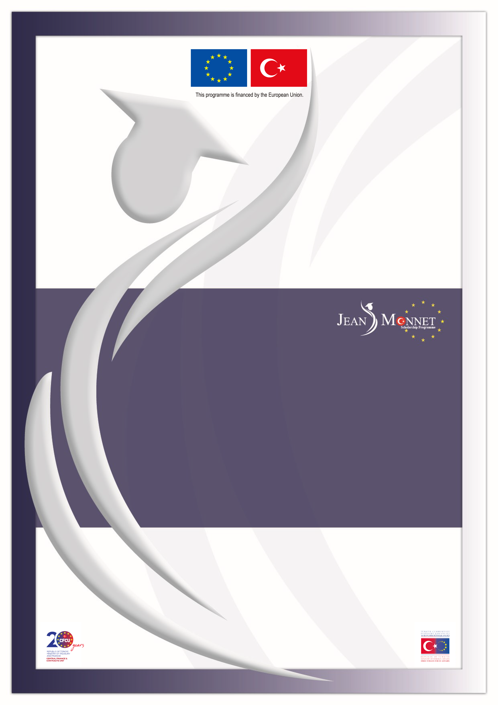

Directorate for EU Affairs Central Finance and Contracts Unit Delegation of the EU to Turkey

TR2020/DG/03/A2-01
2023-2024 ACADEMIC YEAR
JEAN MONNET SCHOLARSHIP PROGRAMME
(Issued by the CFCU on 12 September 2022 with deadline of 15 November 2022)
CLARIFICATIONS

IMPORTANT NOTICE
The questions received from potential applicants for the 2023-2024 academic year Jean Monnet Scholarship Programme together with their answers can be seen below. These questions and answers are valid for the 2023-2024 academic year Announcement and the questions and clarifications of the previous academic years do not set a precedent for the mentioned academic year.

Clarifications constitute an essential part of the Announcement; for this reason, the applicants must read the Clarifications document very carefully and pay attention to the details while applying to the scholarship.

Please note that the replies given to the questions on the eligibility are provided solely for the question asked without consideration of whether the other eligibility criteria stated in the Announcement are fulfilled or not.

As stated in Section 2.3.3. Important Notes for Application of the 2023-2024 Academic Year Jean Monnet Scholarship Programme Announcement, questions related to the issues clearly stated in the Announcement document will not be answered in the Clarifications document.

Please further note that prior opinion/approval cannot be given on:
- the acceptability/adequacy of the application documents,
- the sector from which the applicant should make an application,
- the acceptability/adequacy of the “work experience/graduate degree” to be submitted for satisfying the “min 36-month work experience/graduate (master’s/PhD) degree” criterion,
- the eligibility of the academic programmes to be pursued,
- the relevance of the field of study (i.e. EU acquis chapter) with the academic programmes planned to be pursued,
- the eligibility of the modality of programmes (e.g. contents including online courses).
FOREIGN LANGUAGE PROFICIENCY DOCUMENTS
1 | Q: Is the IELTS requirement minimum 6.5 overall score or 6.5 for each of the modules such as speaking, reading, etc.?  C: Overall scores will be taken into consideration.
2 | Q: Should I take IELTS Academic on computer or paper?  C: Both are acceptable for application to the Scholarship Programme.
3 | Q: Is PTE Academic UKVI acceptable for application to Jean Monnet Scholarship Programme?  C: Yes. Please see Corrigendum-I.
4 | Q: Is PTE Academic Online acceptable for application to Jean Monnet Scholarship Programme?  C: No.
5 | Q: Can our foreign language proficiency test result be sent directly from the exam centre?  C: It is solely the applicant’s responsibility to submit the application documents in a complete form to the Central Finance and Contracts Unit until the application deadline. If need arises to send any document after the submission of the application (not later than the application deadline), a petition letter explaining the situation in detail should also be attached to the document.
SECTOR
6 | Q: I am working part-time at a public institution. May I apply to the scholarship as a public employee?  C: Yes, so long as you submit all the application documents related to the relevant sector.
7 | Q: Can a probationary officer working at a public institution apply to the programme?  C: There are no restrictions related to the service period/position/title for any sector to apply the Scholarship Programme.
8 | Q: I have graduated from one of my major undergraduate programmes. I am still enrolled to the other major undergraduate programme. May I apply?  C: Yes, as long as you are registered as a senior student to your other major undergraduate programme you may apply.
9 | Q: I am a senior student in an open education (Açık Öğretim) undergraduate programme. May I apply?  C: Yes.
10 | Q: Due to insufficient credits, I will appear as a 3rd year student in my transcript document at the time of application. However, I will be a final year student in spring term and graduate in 2022-2023 academic year. May I apply?  C: Senior undergraduate students who are expected to graduate before the contracting process may apply to the Scholarship Programme. Although prior opinion/approval cannot be given on the adequacy of the application documents, it is recommended to submit supporting documents (preferably taken from the university) explaining this situation.
11 | Q: My undergraduate programme has been extended one more semester. Therefore, I am in the 5th year of a 4-year programme. May I apply as a senior undergraduate student?  C: Yes. As long as applicants are registered as senior undergraduate students at the time of application, having extended their programmes does not form a problem. Please also note that awardees who were senior undergraduate students while applying to this Announcement, should submit a Graduation Certificate/Diploma related to their undergraduate programme before contract signature.
12 | Q: I am currently a senior undergraduate student and will graduate in January-February 2023. Looking at the application criteria it appears I am eligible to apply. However, during the written exam and at the time the scholarships are granted I will be unemployed. May I still benefit from the scholarship to pursue graduate study/research?  C: Yes. As long as applicants are registered as senior undergraduate students at the time of application, having graduated and being unemployed in the following stages does not form a problem. Please also note that awardees who were senior undergraduate students while applying to this Announcement, should submit a Graduation Certificate/Diploma related to their undergraduate programme before contract signature.
13 | Q: I will apply as a graduate student enrolled to a programme in Turkey. When I am awarded, I will have to suspend my programme in Turkey. Would it be a problem for application?  C: Those who apply as a graduate student are expected to submit a student certificate or diploma when they are awarded. It is up to the scholar's decision whether to leave or suspend their current programmes after award.
14 | Q: Currently I am a student of a graduate programme organized in cooperation with Ankara University-World Intellectual Property Organization (WIPO)-TÜRKPATENT. The programme has WIPO Distance Learning module for 1 semester. Since I am registered to Ankara University, may apply for a scholarship?  C: Yes. Senior undergraduate or graduate (master’s or PhD) students of the distance learning programmes in the universities in Turkey may apply for the Jean Monnet Scholarship Programme.
15 | Q: I am enrolled to a graduate programme without dissertation in Turkey. May I apply from university sector?  C: Yes. Students who are enrolled to a graduate programme in a university in Turkey with or without a dissertation may apply.
16 | Q: I am a Turkish citizen currently pursuing graduate study abroad and at the same time working in the private sector in Turkey. Can I apply to Jean Monnet Scholarship Programme?  C: Those who meet the required criteria and who can submit the required documents of the private sector may apply.
17 | Q: I am currently working in the overseas office of a company with Turkey headquarters. May I apply for a scholarship?  C: Prior opinion/approval cannot be given for the eligibility of an applicant. In order to be eligible, the applicants should be working in an institution “in Turkey” and submit all the relevant documents specified in the Announcement. Please also see section 2.1 of the Announcement for further details.
18 | Q: I am on internship in the private sector for which I am being paid fee. Can I apply for a scholarship?  C: Social security registration under “internship” profession code only covers accidents at work and occupational diseases and therefore does not correspond to professional work. Accordingly, only applications from candidates whose retirement insurance premiums are paid is acceptable.
19 | Q: I am currently on unpaid leave from my employer institution. Would it be a problem for application?  C: Being on paid/unpaid leave would not be a problem if you could submit all the necessary documents required from the relevant sector.
20 | Q: Do I have to work until contract signature date specified in the Indicative Timetable (i.e. 15 August 2023-15 December 2023) or is it sufficient to work until application deadline?  C: Those who applied as employees from the “public or private sector” or as academic or administrative staff from the “university sector” should still be working in the sector they applied from once they are notified that they have been recommended for award of a scholarship and will be requested to submit relevant supporting documents. In case an applicant fails to submit the requested documents, they will not be allowed to continue the contracting process and will be deemed to be withdrawn from the scholarship. Also, it is important to keep in mind that the dates specified in the Indicative Timetable are “provisional dates”.
21 | Q: What happens if the applicant leaves work permanently or has periods of unemployment during the "application process"?  C: To be eligible to apply the Scholarship Programme, an applicant must be working in private sector/public sector/university sector as academic or administrative staff, or studying in a university as senior undergraduate student/graduate student at the time of application as evidenced by the supporting documents they will be submitting. Please also see C.20.
22 | Q: I already have a graduate degree; can I apply to the Jean Monnet Scholarship Programme for a second graduate study?  C: Yes, as long you fulfil the eligibility criteria stated in the Announcement, you may apply.
23 | Q: I am currently a trainee lawyer; however, my traineeship will be completed soon after the application deadline. Can I apply for a scholarship?  C: No, applicants who are interns, trainee lawyers or volunteers cannot be considered as eligible in the scope of ‘working in the public sector/private sector/universities in Turkey’ and cannot apply for the scholarship since “working” means “professional work done under a social security network in return for a wage. Please also see C.24.
24 | Q: Based on the amendment of the Attorneyship Law, being employed under a social security system will not form a barrier to pursue legal internship as long as it does not present a factual obstacle to the internship. May I apply for a scholarship if I work in the public or private sector under social security during my internship period?  C: Yes.
FIELD OF STUDY
25 | Q: May I apply to pursue a Master’s programme in my field of study chosen at the application or does it have to be related to the field I graduated from?  C: Choosing the field of study while filling in the application form and ensuring the compliance of the academic study to be pursued with the field of study chosen are solely under the responsibility of the applicants. The Jean Monnet Scholarship Programme considers the compliance of the study field selected with the field of the academic programme to be pursued as well as compliance with the objective of the scholarship. In this manner, the Scholarship Programme does not take into consideration the compliance of the selected academic programme with the academic or professional background of the applicant.
HOSTING INSTITUTIONS/COUNTRIES
26 | Q: Is there a list of programmes suitable for Jean Monnet Scholarship Programme criteria?  C: It is solely the applicants’ responsibility to identify the suitable academic programmes in line with their field of study and to obtain offer letter(s) from the academic programmes. Applicants may refer to the Jean Monnet Scholarship Programme Hosting Institutions Catalogue (available in www.jeanmonnet.org.tr) for examples of graduate programmes in the fields they wish to study. However, eligible programmes are not restricted to the programmes/institutions listed in the subject catalogue.
27 | Q: Why is there no institution from the United Kingdom listed in the catalogue?  C: The Hosting Institutions Catalogue is shared in the aim of introducing study programmes in EU member countries other than the United Kingdom. Please also see C.26 and C.28.
28 | Q: Is the United Kingdom an eligible host country?  C: Yes. United Kingdom is an eligible host country for the 2023-2024 academic year.
TYPE OF ACADEMIC STUDIES
29 | Q: Are scholarships granted for post-doctoral study or research?  C: Jean Monnet Scholarships are not limited for master’s degrees only, meaning that scholarships can be granted for post-doctoral studies or research levels for periods of minimum 3 months, maximum 12 months. Academic studies longer than 12 months will not be supported even if the scholars are willing to fund the remaining period by their own means.
30 | Q: Does Jean Monnet Scholarship Programme support foreign language training?  C: No. Jean Monnet Scholarship Programme supports graduate or research level academic studies only.
31 | Q: With reference to the phrase “in universities or similar institutions” mentioned in the Announcement, what type of similar institutions are referred to?  C: "Similar institutions" refers to educational institutions dedicated to higher education and research, which offer academic programmes in the selected study field.
32 | Q: Can we pursue a fully online programme (masters or research) if we are awarded Jean Monnet Scholarship?  C: No, in line with the aim of the Scholarship Programme, distance learning (fully online) programmes are not acceptable.
APPLICATION DOCUMENTS
33 | Q: The date I indicated in the application form and the date I posted the documents are different, will this cause a problem?  C: No, the date in the application form will be taken into consideration while assessing submitted documents.
34 | Q: My name has been changed by court decision. In some of my application documents such as undergraduate diploma, transcript etc. my previous name is indicated. What kind of a document should I submit describing change of name?  C: Applicants whose name or surname appear different in application documents should submit an official document demonstrating the change of name/surname such as court decision, marriage certificate etc.
35 | Q: I am a senior undergraduate student. There is a minimum 2.70 CGPA requirement for Jean Monnet scholarship applications. Is the current CGPA or CGPA at graduation taken into account?  C: For senior undergraduate students the CGPA at the time of application is taken into consideration.
36 | Q: Is it accepted if the barcode on the undergraduate transcript to be used in the scholarship application is included in the cover letter?  C: Prior opinion/approval cannot be given on the adequacy of the application documents. It is solely the applicants' responsibility to prove submitted documents satisfy the requirements set in the Announcement.
37 | Q: The faculty I graduated from has been transferred to another university. Therefore, my transcript has the new university's name even though my diploma includes the previous university's name. Which university's name should I indicate in the application form?  C: You may write the name of the university officially indicated in your diploma in the application form. A letter explaining the situation is recommended to be added to your application.
38 | Q: I earned my undergraduate degree in X Country. My undergraduate CGPA is in a different grading system and I cannot submit a conversion document. Since I have certification of Higher Education Council (YÖK) equivalency, may I apply?  C: No, all applicants whose undergraduate CGPA is in a different grading system (e.g. 20, 10 or non-numerical grading) should submit a conversion document such as an official letter/e-mail from the applicant’s university or the university’s regulation showing the equivalence of his/her CGPA in the acceptable grading systems (i.e. 100 or 4.00). The applicants, who will submit a conversion document to 4.00-based or 100-based grading system, should also submit their undergraduate transcripts.
39 | Q: I completed my undergraduate and graduate degrees in X country and I have certification of Higher Education Council (YÖK) equivalency, can I apply for a scholarship?  C: The country where the undergraduate degree has been obtained or whether it has equivalence certification from the Higher Education Council is not a scholarship application criteria. On the other hand please bear in mind that those who have earned a graduate degree (master’s or PhD) abroad by benefitting from another scholarship funded by an EU member country or the UK or an EU institution cannot apply. Please also see C.38.
40 | Q: Does the consent letter / employment document / payroll from the employer institution of an applicant have to be translated or is the Turkish version accepted?  C: Documents prepared by the employer in Turkish or in English are accepted.
41 | Q: As a public sector employee, am I expected to submit a consent letter or an employment letter when I am awarded a scholarship?  C: Public sector employees are expected to submit an official letter from the employer which fulfils the criteria specified in the section 2.6 of the Announcement indicating that the award holder is currently working in that public institution.
42 | Q: Since I am a contracted teacher working at a public school, I do not have an “Institutional Registry Number” (Sicil Numarası) included in the consent letter. Would it be a problem?  C: No, it is not obligatory to use Annex 20-Recommended Format for Consent Letter. However, the consent letter to be submitted should satisfy the criteria set in the Section 2.3.1.1. of the Announcement.
43 | Q: I have my own company, however, I am retired and therefore cannot submit a service scheme. May I apply for a scholarship?  C: Applicants should submit all the required documents specified in the Announcement. The applicants who take their salary within the structure of their own company/firm should refer the note in the section 2.3.1.2 of the Announcement.  Although prior opinion/approval cannot be given on the adequacy of the application documents, if you are exempted from social security system in the Republic of Turkey by law, you are recommended to submit supporting official documents to prove your exemption.
44 | Q: Is it sufficient to submit only one payroll sheet that belongs to August 2022 or later?  C: Yes.
45 | Q: I am working in an international organisation. What type of document should I submit to prove a SGK exemption status?  C: Those whose institutions are exempted from social security system in the Republic of Turkey by an international treaty or law may apply for the scholarship so long as they prove their exemptions with the mentioned legal documents. Applicants may submit an official document showing their own exemption status (such as a letter from the employee organisation). In case you are working at an institution where pension premiums are collected in its own employee pension fund, you should submit a document showing these pension premiums.
WRITTEN EXAM
46 | Q: Is everyone who meets the minimum application criteria invited to the exam to be held in Ankara?  C: Yes.
47 | Q: Is a list of written exam sample questions from past years published? If not, which subjects are applicants expected to cover? Can you recommend a source or website for us to study in preparation for the written exam?  C: Due to Programme regulations, written exam questions of past academic years are not shared. In the Written Exam, various questions related to the EU acquis chapter from which the applicant applied, European Union and EU-Turkey relations can be asked. It is recommended to visit the websites of the Directorate for EU Affairs (www.ab.gov.tr), the Delegation of the European Union to Turkey (www.avrupa.info.tr) and the European Commission (https://ec.europa.eu/info/index_en) for detailed information on the study fields. For detailed information, please see the section 2.4 of the Announcement.
OTHER
48 | Q: I am unable to download the Announcement document from your website, is there any way you can send us the subject document?  C: The Announcement document on all websites has been tested and can be downloaded. You are recommended to try again from any of the following websites; Central Finance and Contracts Unit (https://cfcu.gov.tr/tender/66070), Directorate for EU Affairs (www.ab.gov.tr), the Delegation of the European Union to Turkey (www.avrupa.info.tr) or try downloading the documents with a different browser/computer.
49 | Q: According to the “Regulation on Civil Servants to be sent Abroad for Training”, there is an age limit of 40 for master's degree and 50 for research. Since I am over 40, should I apply with a research project or can I apply to JMSP for post-doc?  C: There is no age limit to apply for the Jean Monnet Scholarship Programme; however, applicants’ home institutions (especially public institutions) may apply an age limit based on the relevant legislations. The issue of how public employees will be assigned is at the discretion and authorization of the institutions that they are affiliated to.
50 | Q: As a dual citizen, my Turkish ID and Bulgarian passport names are different. I am registered as a Turkish student in a university in Turkey, but I will apply to graduate programmes with my Bulgarian passport. Which document should I apply for the Jean Monnet scholarship?  C: Nationals of EU member countries, the United Kingdom, Turkey or Instrument for Pre-Accession Assistance (IPA) beneficiary countries may apply to the Jean Monnet Scholarship Programme. It is at the discretion of the applicant to decide which nationality to use at application. If you are awarded a scholarship, you are expected to submit an official document explaining your situation.
51 | Q: Can we use Turkish characters when filling the English application form?  C: You may use Turkish characters for proper nouns. In case any problem occurs while using Turkish characters, you can use the closest English character.
52 | Q: In cases where the acceptance letter is conditional to pre-sessional tuition or examination, will the scholarship award finance it?  C: No. It is solely the applicants’ responsibility to get unconditional offer letters from the academic programmes.

